**Story Board**

**Task 3**

**P1.3**

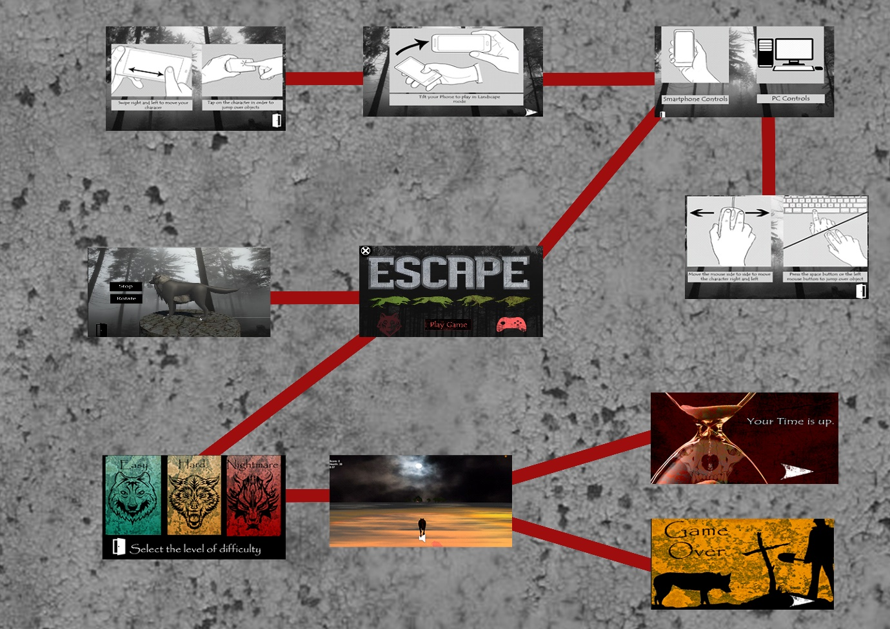

Storyboard

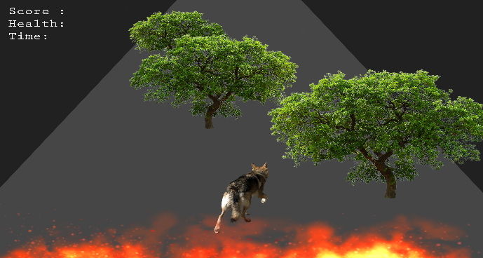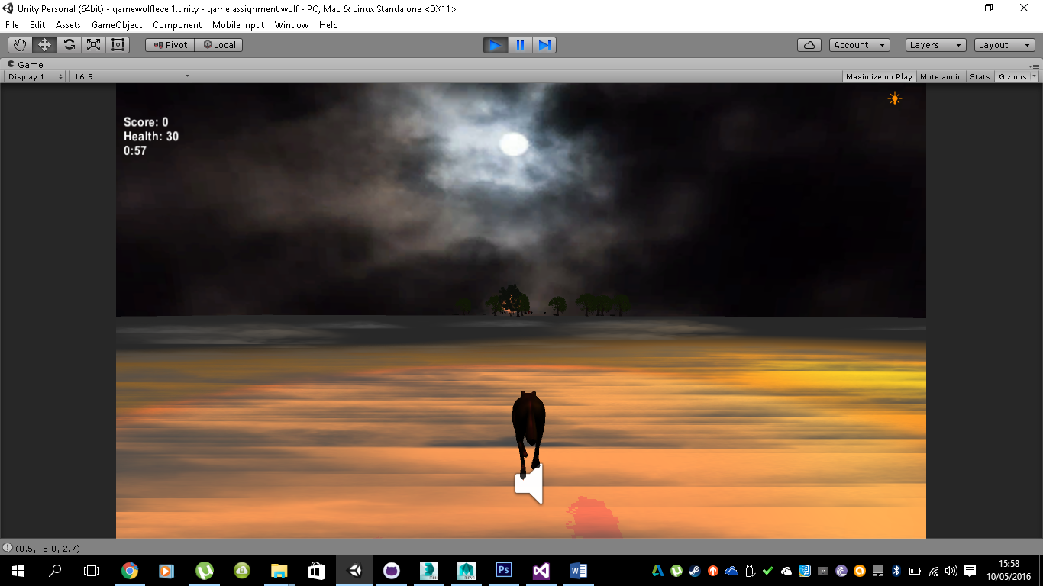

The first two scenes are are an idea of how the game will look when the user is actually playing the game

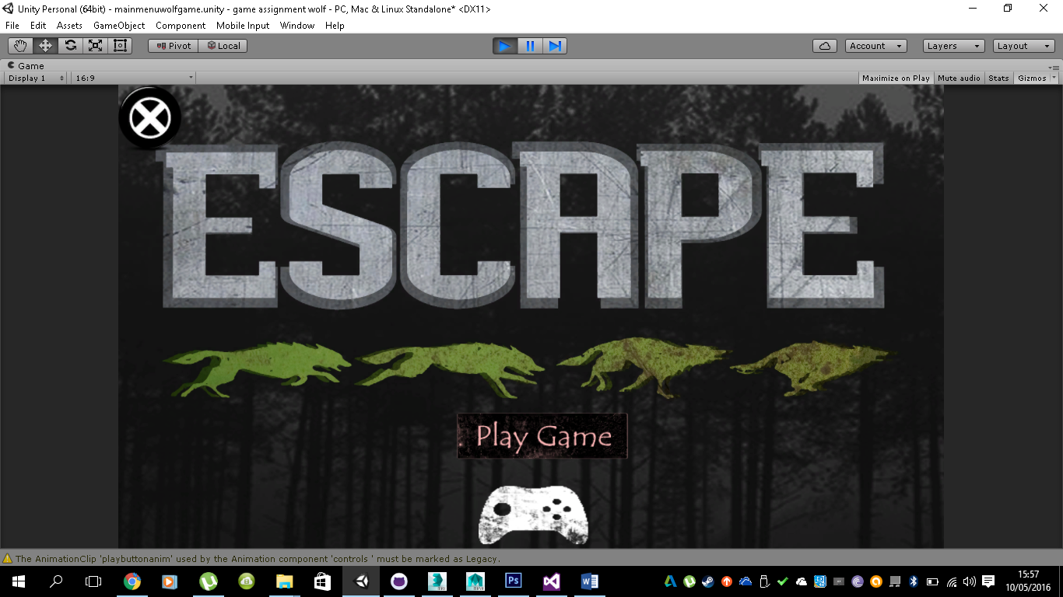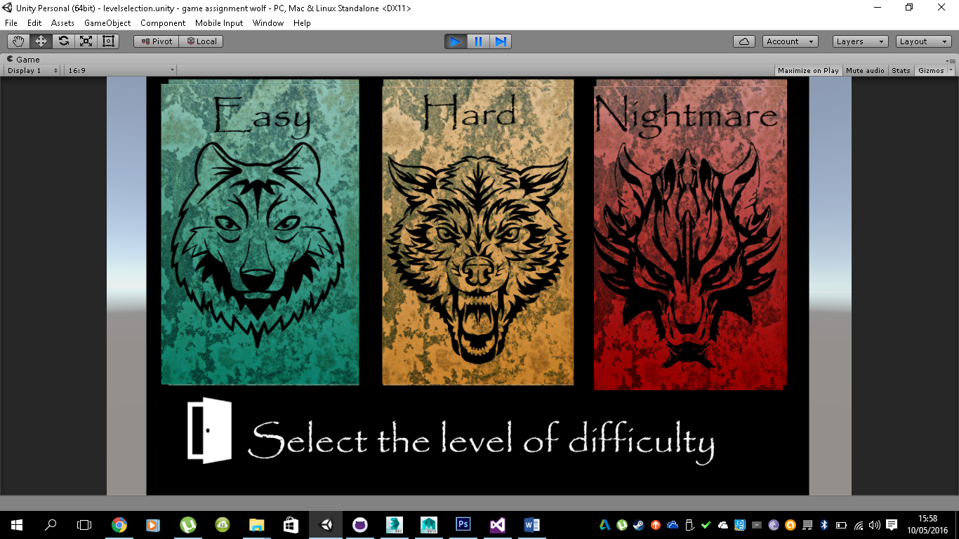

The two scenes above will help the user navigate arround the game, the first scene is the main menu( the main scene) from here the user has 4 options, first is to goin the load scenes page and select the difficulty, second is the instructions button, the user can enter here to se the instructions of the game. The 3rd button will take the user to a page where he/she can view the character they will be suing to play in the game. The last button is the exit button, this is just used on order to shutdown the game.

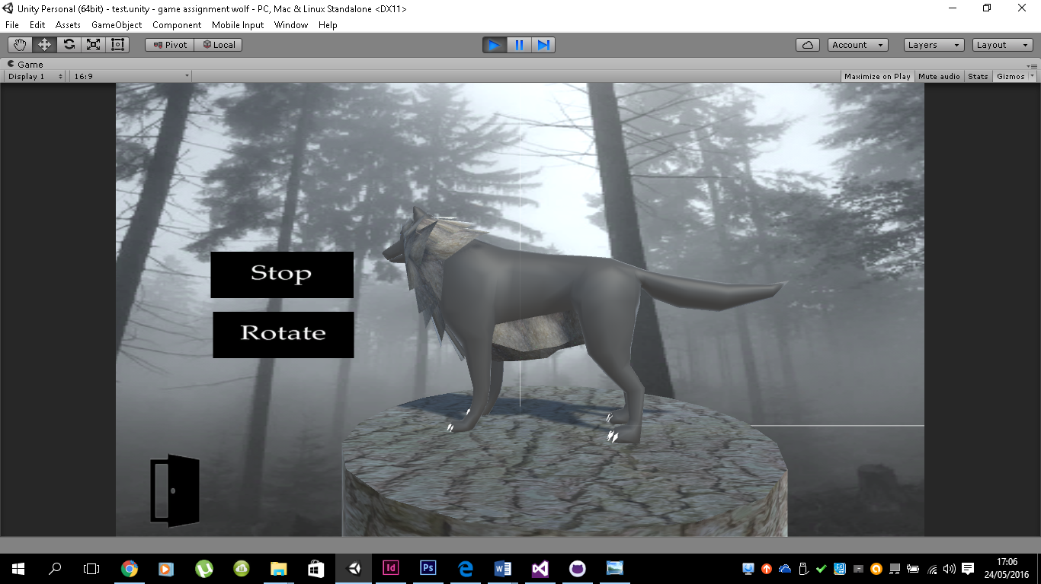

This scene is for the user to have an idea of the character he will be playing, the user can click on the rotate so that the user will get a 36o degree view of the character.

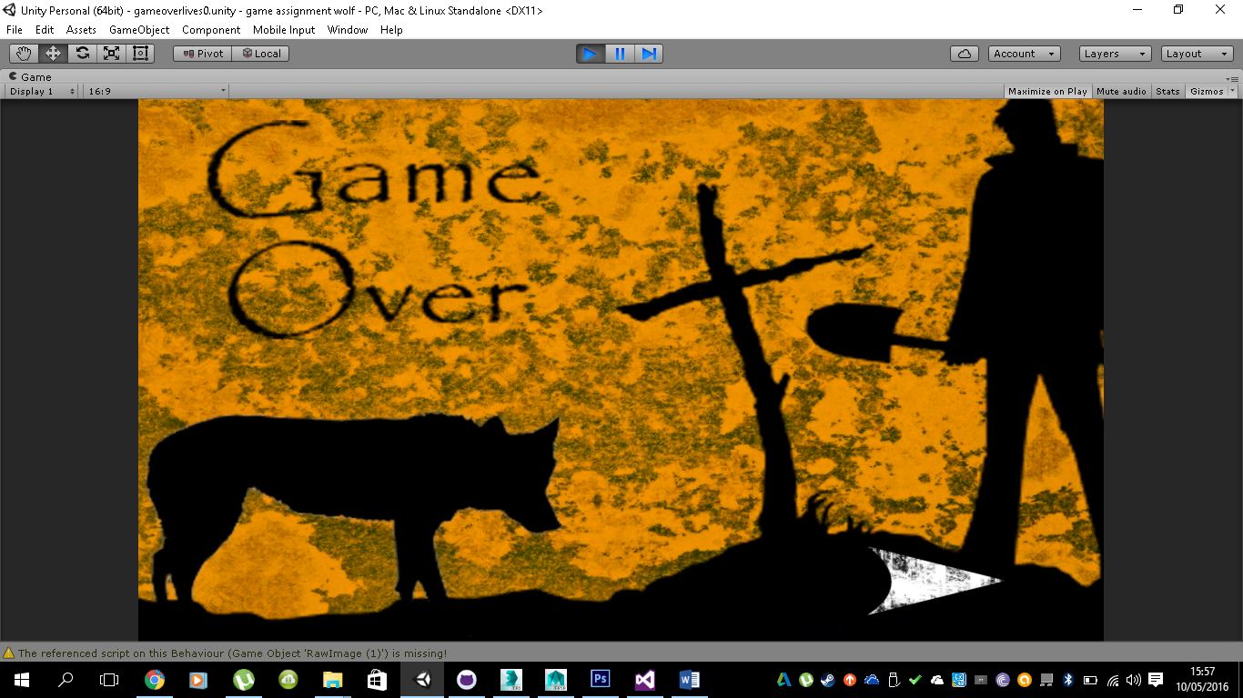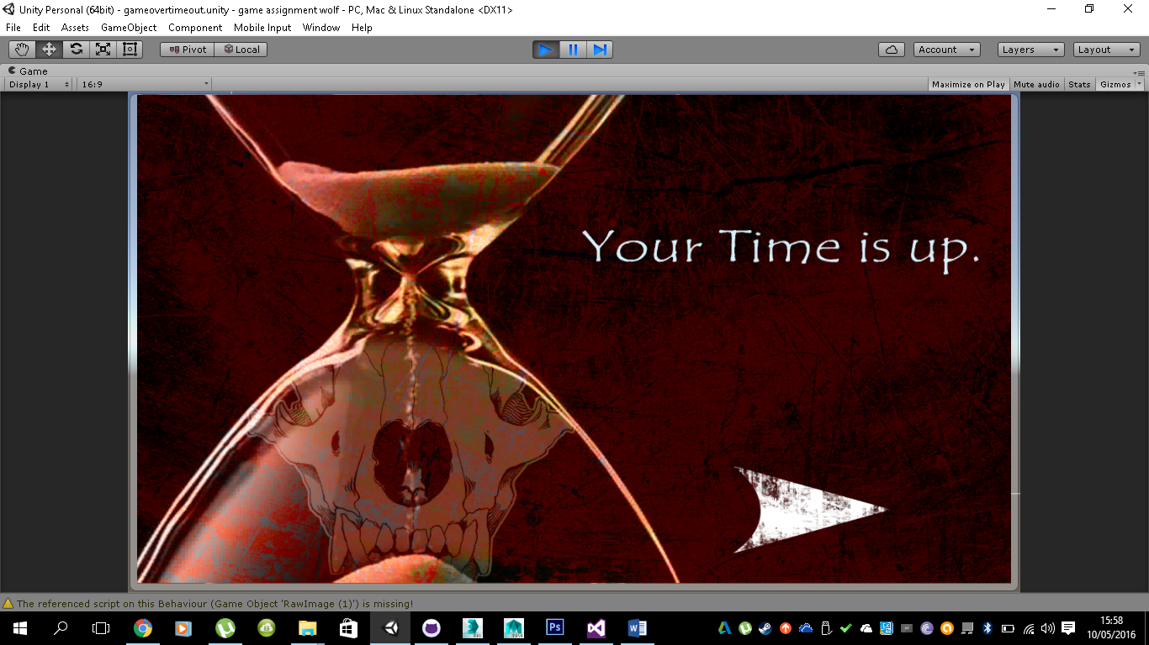

The two scenes above the the game over scenes, in the game ther are two ways in how thegame will end, either the user will loose all the lives(in which case the wolf dies) and by allowing time to run out. Idealy the game should end with the timer eraching zero as its just idicating that time ran out and the wolf has survived, while if the wolf runs out of lives its just a clear indication that the user has hot to many obsticles and has lost all of his/her lives.

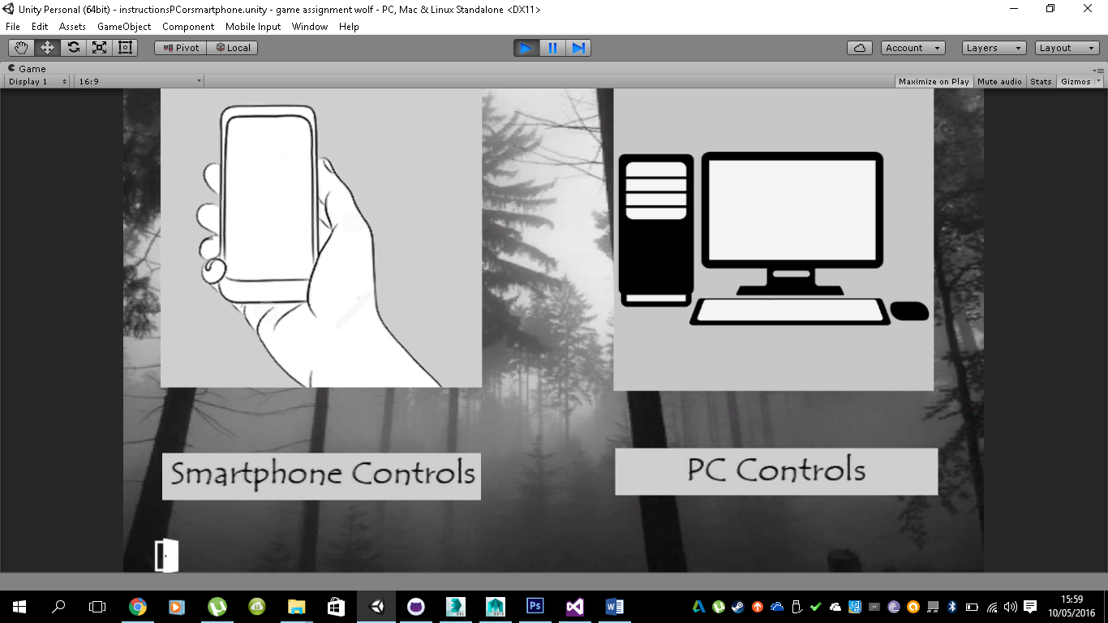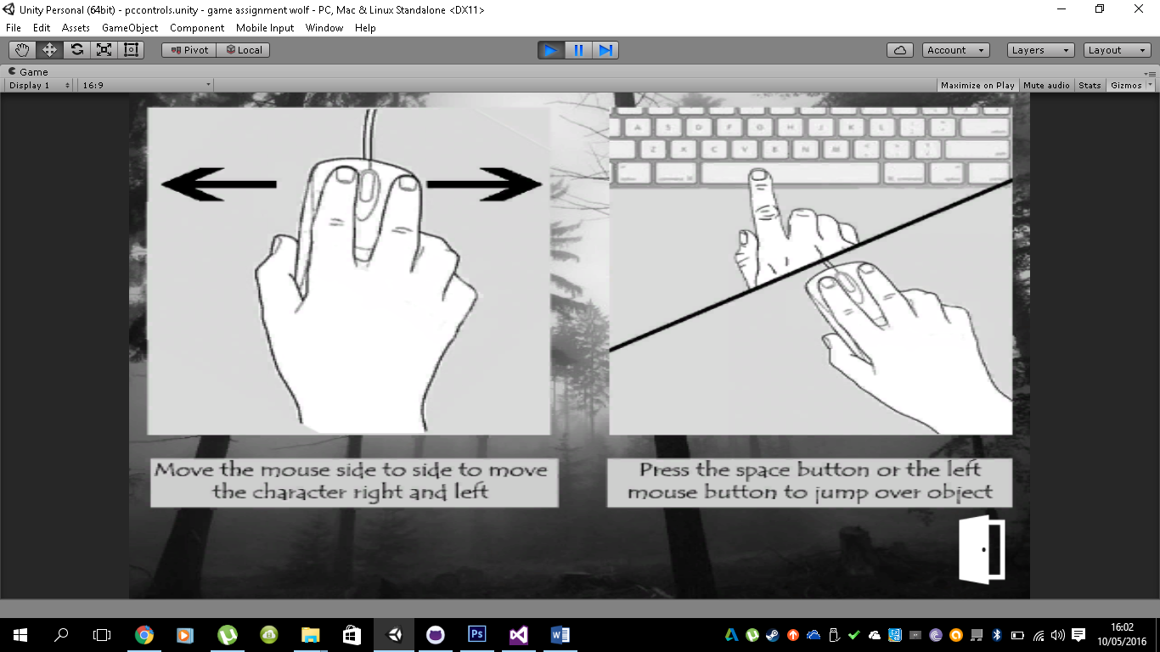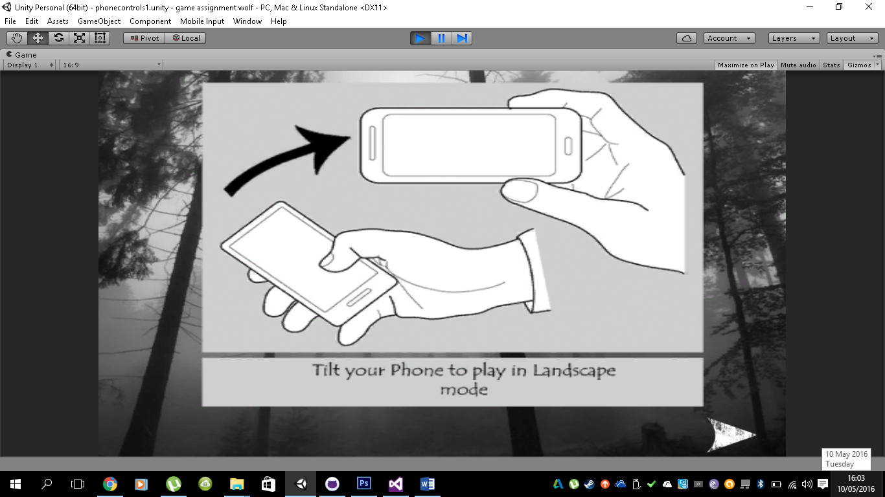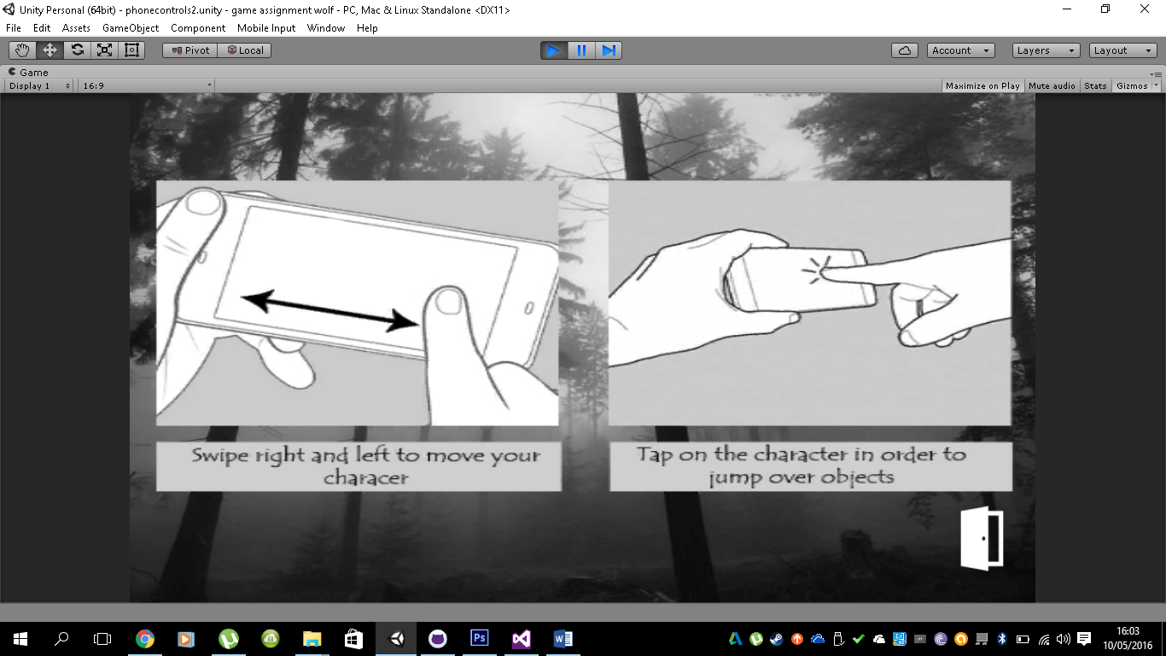

The scenes aboveare the instruction scenes, bassically they show the user how to play the game on both conputer or smartphone.